PROGRAM 1:

**import** java.util.Scanner;

**public** **class** SumAverage {

**public** **static** **void** main(String[] args) {

// **TODO** Auto-generated method stub

**int** n, sum=0;

**float** average;

Scanner sc = **new** Scanner(System.***in***);

System.***out***.print("Enter the no of elements ");

n=sc.nextInt();

**int** a[] = **new** **int**[n];

System.***out***.println("Enter the elements ");

**for**(**int** i = 0; i < n; i++) {

a[i] = sc.nextInt();

sum = sum + a[i];

}

System.***out***.println("Sum of the array : " +sum);

average = (**float**)sum/n;

System.***out***.println("Average = " +average);

}

}

OUTPUT:

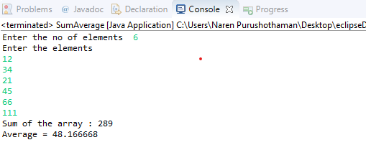

PROGRAM 2:

**public** **class** MaxMinArray{

**public** **static** **void** main(String args[]){

**int** array[] = **new** **int**[] {10,22,34,56,9,567,432};

// Calling getMax() method for getting max value

**int** max = *getMax*(array);

System.***out***.println("Maximum Value is: "+max);

// Calling getMin() method for getting min value

**int** min = *getMin*(array);

System.***out***.println("Minimum Value is: "+min);

}

// Method for getting the maximum value

**public** **static** **int** getMax(**int**[] inputArray){

**int** maxValue = inputArray[0];

**for**(**int** i=1;i < inputArray.length;i++){

**if**(inputArray[i] > maxValue){

maxValue = inputArray[i];

}

}

**return** maxValue;

}

// Method for getting the minimum value

**public** **static** **int** getMin(**int**[] inputArray){

**int** minValue = inputArray[0];

**for**(**int** i=1;i<inputArray.length;i++){

**if**(inputArray[i] < minValue){

minValue = inputArray[i];

}

}

**return** minValue;

}

}

OUTPUT:

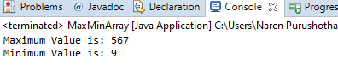

________________________________________________________________

PROGRAM 3:

**import** java.util.Scanner;

**public** **class** SearchElement

{

**public** **static** **void** main(String[] args)

{

**int** n, x, flag = 0, i = 0;

Scanner sc = **new** Scanner(System.***in***);

System.***out***.print("Enter no. of elements you want in array:");

n = sc.nextInt();

**int** a[] = **new** **int**[n];

System.***out***.println("Enter all the elements:");

**for**(i = 0; i < n; i++)

{

a[i] = sc.nextInt();

}

System.***out***.print("Enter the element you want to find:");

x = sc.nextInt();

**for**(i = 0; i < n; i++)

{

**if**(a[i] == x)

{

flag = 1;

**break**;

}

**else**

{

flag = 0;

}

}

**if**(flag == 1)

{

System.***out***.println("Element found at position:"+(i + 1));

}

**else**

{

System.***out***.println("Element not found");

}

}

}

OUTPUT:

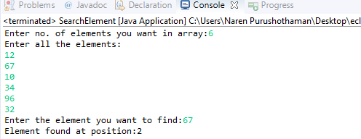

PROGRAM 4:

**public** **class** ASCIItoChar {

**public** **static** **void** main(String[] args) {

**int** num[] = **new** **int**[] {65, 120, 98, 75, 115};

String str = **null**;

**for**(**int** i : num) {

str = Character.*toString*((**char**)i);

System.***out***.println(str);

}

}

}

OUTPUT:

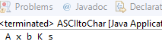

PROGRAM 5:

* Two Largest Numbers in the array

**import** java.util.Scanner;

**public** **class** MaxMin2

{

**public** **static** **void** main (String[] args)

{

Scanner scn = **new** Scanner (System.***in***);

System.***out***.print("Enter no. of elements you want in array:");

**int** n = scn.nextInt();

**int** array[] = **new** **int**[n];

System.***out***.println("Enter all the elements:");

**for** (**int** i = 0; i < array.length; i++)

{

array[i] = scn.nextInt();

}

**int** largest1, largest2, temp;

largest1 = array[0];

largest2 = array[1];

**if** (largest1 < largest2)

{

temp = largest1;

largest1 = largest2;

largest2 = temp;

}

**for** (**int** i = 2; i < array.length; i++)

{

**if** (array[i] > largest1)

{

largest2 = largest1;

largest1 = array[i];

}

**else** **if** (array[i] > largest2 && array[i] != largest1)

{

largest2 = array[i];

}

}

System.***out***.println ("The First largest is " + largest1);

System.***out***.println ("The Second largest is " + largest2);

}

}

OUTPUT:

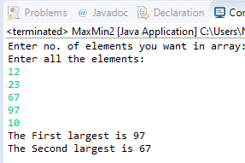

* Two Smallest Numbers in the array:

**import** java.io.*;

**class** SecondSmallest

{

**static** **void** print2Smallest(**int** arr[])

{

**int** first, second, arr_size = arr.length;

**if** (arr_size < 2)

{

System.***out***.println(" Invalid Input ");

**return**;

}

first = second = Integer.***MAX_VALUE***;

**for** (**int** i = 0; i < arr_size ; i ++)

{

**if** (arr[i] < first)

{

second = first;

first = arr[i];

}

**else** **if** (arr[i] < second && arr[i] != first)

second = arr[i];

}

**if** (second == Integer.***MAX_VALUE***)

System.***out***.println("There is no second" +

"smallest element");

**else**

System.***out***.println("The smallest element is " +

first + " second Smallest" +

" element is " + second);

}

**public** **static** **void** main (String[] args)

{

**int** arr[] = {12, 13, 1, 10, 34, 1};

*print2Smallest*(arr);

}

}

OUTPUT:

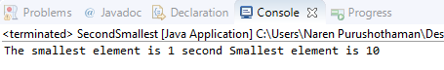

PROGRAM 6:

**public** **class** SortedArray {

**public** **static** **void** main(String[] args) {

**int** [] arr = **new** **int** [] {5, 2, 8, 7, 1};

**int** temp = 0;

System.***out***.println("Elements of original array: ");

**for** (**int** i = 0; i < arr.length; i++) {

System.***out***.print(arr[i] + " ");

}

**for** (**int** i = 0; i < arr.length; i++) {

**for** (**int** j = i+1; j < arr.length; j++) {

**if**(arr[i] > arr[j]) {

temp = arr[i];

arr[i] = arr[j];

arr[j] = temp;

}

}

}

System.***out***.println();

System.***out***.println("Elements of array sorted in ascending order: ");

**for** (**int** i = 0; i < arr.length; i++) {

System.***out***.print(arr[i] + " ");

}

}

}

OUTPUT:

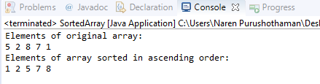

PROGRAM 7:

**public** **class** RemoveDuplicate {

**public** **static** **int** removeDuplicateElements(**int** arr[], **int** n){

**if** (n==0 || n==1){

**return** n;

}

**int**[] temp = **new** **int**[n];

**int** j = 0;

**for** (**int** i=0; i<n-1; i++){

**if** (arr[i] != arr[i+1]){

temp[j++] = arr[i];

}

}

temp[j++] = arr[n-1];

**for** (**int** i=0; i<j; i++){

arr[i] = temp[i];

}

**return** j;

}

**public** **static** **void** main (String[] args) {

**int** arr[] = {10,20,20,30,30,40,50,50};

**int** length = arr.length;

length = *removeDuplicateElements*(arr, length);

//printing array elements

**for** (**int** i=0; i<length; i++)

System.***out***.print(arr[i]+" ");

}

}

OUTPUT:

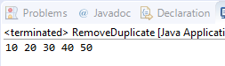

PROGRAM 8:

**import** java.util.*;

**public** **class** FreqElement {

**static** **int** mostFrequent(**int** arr[], **int** n)

{

Arrays.*sort*(arr);

**int** max_count = 1, res = arr[0];

**int** curr_count = 1;

**for** (**int** i = 1; i < n; i++) {

**if** (arr[i] == arr[i - 1])

curr_count++ ;

**else**

{

**if** (curr_count > max_count)

{

max_count = curr_count;

res = arr[i - 1];

}

curr_count = 1;

}

}

**if** (curr_count > max_count)

{

max_count = curr_count;

res = arr[n - 1];

}

**return** res;

}

**public** **static** **void** main (String[] args) {

**int** arr[] = { 1,2,3,2,1,5,1,6 };

**int** n = arr.length;

System.***out***.println("Maximum element is " +*mostFrequent*(arr,n));

}

}

OUTPUT:

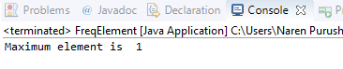

PROGRAM 9:

**import** java.io.*;

**public** **class** SumExclude {

**static** **void** sumexcludingrange(**int** li[], **int** a, **int** b) {

**int** sum = 0;

**boolean** add = **true**;

**for** (**int** i = 0; i < li.length; i++) {

**if**(li[i] != a && add == **true**)

sum = sum + li[i];

**else** **if**(li[i] == a)

add = **false**;

**else** **if**(li[i] == b)

add = **true**;

}

System.***out***.println("Sum excluding a and b are "+sum);

}

**public** **static** **void** main(String[] args) {

**int** li[] = {1,2,4,5,6,7,8};

**int** a = 1;

**int** b = 2;

*sumexcludingrange*(li, a, b);

}

OUTPUT:

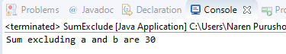

PROGRAM 10:

**public** **class** ReverseArray {

**public** **static** **void** main(String args[])

{

**int** a=args.length;

**int** x,y,w,z,i;

**int** arr[][] = **new** **int**[4][4];

**if**(a<4)

{

System.***out***.println("enter 4 values");

}

**if**(a==4)

{

**int** k=0;

**for**(i=0;i<2;i++)

{

**for**(**int** j=0;j<2;j++)

{

arr[i][j]=Integer.*parseInt*(args[k]);

k++;

}

}

System.***out***.println("The given array is:");

**for**(i=0;i<2;i++)

{

**for**(**int** j=0;j<2;j++)

{

System.***out***.print(arr[i][j]+" ");

}

System.***out***.println();

}

System.***out***.println("The reverse of array is:");

**for**(i=1;i>=0;i--)

{

**for**(**int** j=1;j>=0;j--)

{

System.***out***.print(arr[i][j]+" ");

}

System.***out***.println();

}

}

}

}

OUTPUT:

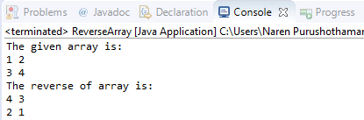

PROGRAM 11:

**public** **class** GreatestElementMatrix {

**public** **static** **void** main(String[] args) {

**if** (args.length != 9)

System.***out***.println("Please enter 9 integer numbers");

**int**[][] array = **new** **int**[3][3];

**int** x = 0;

// storing input to 2d array

**for** (**int** i = 0; i < array.length; i++) {

**for** (**int** j = 0; j < array[0].length; j++) {

array[i][j] = Integer.*parseInt*(args[x++]);

}

}

**int** max = 0;

// getting max of array

**for** (**int** i = 0; i < array.length; i++) {

**for** (**int** j = 0; j < array[0].length; j++) {

max = array[i][j] > max ? array[i][j] : max;

}

}

System.***out***.println("The biggest number in the given array is " + max);

}

}

OUTPUT:

